**Practical No. 04**

**Remote Object Communication**

**Q.1 Using MySQL create Library database. Create table Book (Book_id, Book_name, Book_author) and retrieve the Book information from Library database using Remote Object Communication concept.**

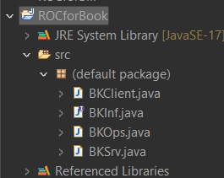

**Code:**

**BKSrv.java**

import java.rmi.Naming;

import java.rmi.registry.LocateRegistry;

public class BKSrv {

public BKSrv() {

super();

}

public static void main(String[] args) {

// TODO Auto-generated method stub

try {

BKInf skeleton = new BKOps();

LocateRegistry.createRegistry(1900);

Naming.rebind("rmi://localhost:1900/ROCforBook", skeleton);

System.out.println("Server Registered");

}catch(Exception e) {

e.printStackTrace();

}

}

}

**BKClient.java**

import java.io.BufferedReader;

import java.io.InputStreamReader;

import java.rmi.Naming;

public class BKClient {

public BKClient() {

super();

}

public static void main(String[] args) {

// TODO Auto-generated method stub

String sql = "", ch = "";

try {

BKInf stub = (BKInf) Naming.lookup("rmi://localhost:1900/ROCforBook");

BufferedReader br = new BufferedReader(new InputStreamReader(System.in));

while(true) {

System.out.println("Select an Option");

System.out.println("1. Retrieve Book Info : ");

System.out.println("2. Insert Book Info : ");

System.out.println("3. Exit ");

System.out.println("Enter Your Choice : ");

ch = br.readLine();

if(ch.equals("1")) {

sql = "select * from libData";

sql = stub.getData(sql);

}

else if(ch.equals("2")) {

sql = "insert into libData(bookId, bookName, bookAuthor) values (101, 'The Alamack N R', 'Tim Drewes')";

sql = stub.insertData(sql);

}

else if(ch.equals("3")) {

System.exit(0);

}

else {

sql = "Please enter valid Input";

}

System.out.println(sql);

}

}catch (Exception e) {

// TODO: handle exception

e.printStackTrace();

}

}

}

**BKInf.java**

import java.rmi.Remote;

import java.rmi.RemoteException;

public interface BKInf extends Remote{

public String getData(String strQry) throws RemoteException;

public String insertData(String strQry) throws RemoteException;

}

**BKOps.java**

import java.rmi.RemoteException;

import java.rmi.server.UnicastRemoteObject;

import java.sql.Connection;

import java.sql.DriverManager;

import java.sql.ResultSet;

import java.sql.ResultSetMetaData;

import java.sql.Statement;

public class BKOps extends UnicastRemoteObject implements BKInf{

private static final long serialVersionUID = 1L;

Connection con;

Statement stmt;

ResultSet rs;

ResultSetMetaData rsmd;

String colStr, resultStr;

public BKOps() throws RemoteException{

super();

con = null;

stmt = null;

rs = null;

rsmd = null;

colStr = "";

resultStr = "";

}

public void setDBCon() {

try {

String URL = "jdbc:mysql://localhost:3306/librarysys";

Class.forName("com.mysql.jdbc.Driver");

con = DriverManager.getConnection(URL,"root","");

}catch(Exception e) {

e.printStackTrace();

}

}

public String getData(String strQry) throws RemoteException {

try {

setDBCon();

System.out.println("Server Registered");

stmt = con.createStatement();

rs = stmt.executeQuery(strQry);

rsmd = rs.getMetaData();

for (int i = 1; i <= rsmd.getColumnCount(); i++) {

colStr = colStr + rsmd.getColumnName(i) + "\t";

}

while(rs.next()) {

for (int i = 1; i <= rsmd.getColumnCount(); i++) {

resultStr = resultStr + rs.getString(i) + "\t";

}

resultStr = resultStr + "\n";

}

}

catch (Exception e) {

// TODO: handle exception

e.printStackTrace();

}

return colStr + "\n\n" + resultStr;

}

public String insertData(String strQry) throws RemoteException {

try {

setDBCon();

System.out.println("Server Registered");

stmt = con.createStatement();

int recordInserted = stmt.executeUpdate(strQry);

if(recordInserted != 0) {

resultStr = "\nRecord inserted Successfully!";

}else {

resultStr = "\nRecord not inserted Successfully!";

}

}catch (Exception e) {

// TODO: handle exception

e.printStackTrace();

}

return resultStr;

}

}

**Output:**

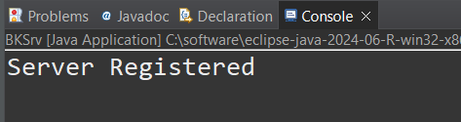

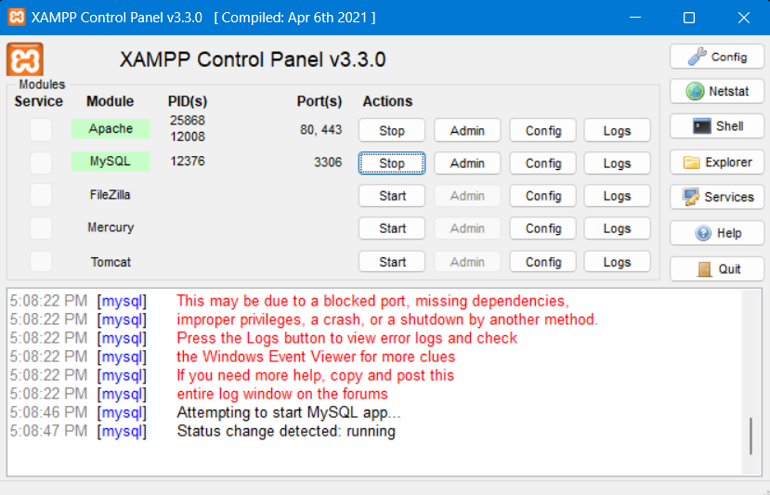

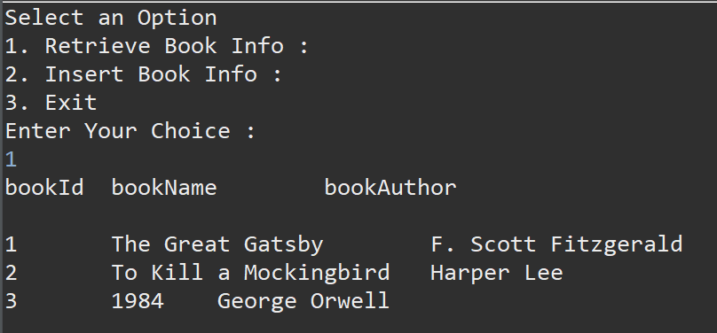

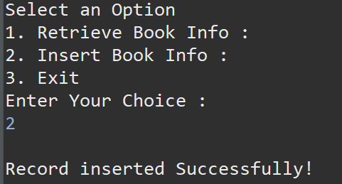 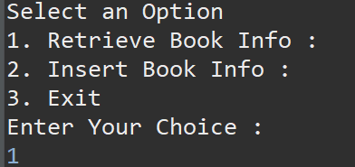

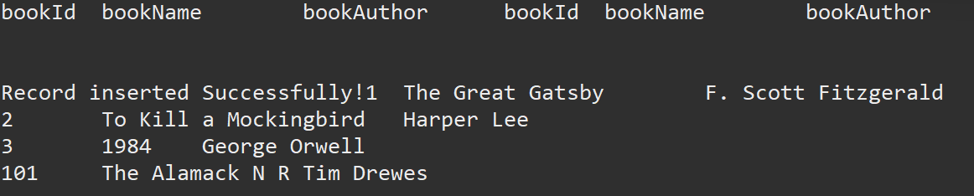

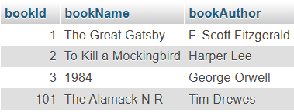

**Q.2 Using MySQL create Electric_Bill database. Create table Bill (consumer_name, bill_due_date, bill_amount) and retrieve the bill information from the Electric_Bill database using Remote Object Communication concept.**

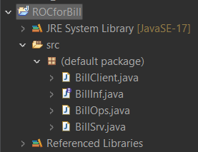

**Code:**

**BillSrv.java**

import java.rmi.Naming;

import java.rmi.registry.LocateRegistry;

public class BillSrv {

public BillSrv() {

super();

}

public static void main(String[] args) {

try {

BillInf skeleton = new BillOps();

LocateRegistry.createRegistry(1900);

Naming.rebind("rmi://localhost:1900/ROCforBill", skeleton);

System.out.println("Server Registered");

}catch(Exception e) {

e.printStackTrace();

}

}

}

**BillClient.java**

import java.io.BufferedReader;

import java.io.InputStreamReader;

import java.rmi.Naming;

public class BillClient {

public BillClient() {

super();

}

public static void main(String[] args) {

String sql = "", ch = "";

try {

BillInf stub = (BillInf) Naming.lookup("rmi://localhost:1900/ROCforBill");

BufferedReader br = new BufferedReader(new InputStreamReader(System.in));

while(true) {

System.out.println("Select an Option");

System.out.println("1. Retrieve Bill Info : ");

System.out.println("2. Insert Bill Info : ");

System.out.println("3. Exit ");

System.out.println("Enter Your Choice : ");

ch = br.readLine();

if(ch.equals("1")) {

sql = "select * from billData";

sql = stub.getData(sql);

}

else if(ch.equals("2")) {

sql = "insert into billData(consumeNm, billDt, billAmt) values ('Onkar', '10-11-2024', 500)";

sql = stub.insertData(sql);

}

else if(ch.equals("3")) {

System.exit(0);

}

else {

sql = "Please enter valid Input";

}

System.out.println(sql);

}

}catch (Exception e) {

e.printStackTrace();

}

}

}

**BillInf.java**

import java.rmi.Remote;

import java.rmi.RemoteException;

public interface BillInf extends Remote{

public String getData(String strQry) throws RemoteException;

public String insertData(String strQry) throws RemoteException;

}

**BillOps.java**

import java.rmi.RemoteException;

import java.rmi.server.UnicastRemoteObject;

import java.sql.Connection;

import java.sql.DriverManager;

import java.sql.ResultSet;

import java.sql.ResultSetMetaData;

import java.sql.Statement;

public class BillOps extends UnicastRemoteObject implements BillInf{

private static final long serialVersionUID = 1L;

Connection con;

Statement stmt;

ResultSet rs;

ResultSetMetaData rsmd;

String colStr, resultStr;

public BillOps() throws RemoteException{

super();

con = null;

stmt = null;

rs = null;

rsmd = null;

colStr = "";

resultStr = "";

}

public void setDBCon() {

try {

String URL = "jdbc:mysql://localhost:3306/billsys";

Class.forName("com.mysql.jdbc.Driver");

con = DriverManager.getConnection(URL,"root","");

}catch(Exception e) {

e.printStackTrace();

}

}

public String getData(String strQry) throws RemoteException {

try {

setDBCon();

System.out.println("Server Registered");

stmt = con.createStatement();

rs = stmt.executeQuery(strQry);

rsmd = rs.getMetaData();

for (int i = 1; i <= rsmd.getColumnCount(); i++) {

colStr = colStr + rsmd.getColumnName(i) + "\t";

}

while(rs.next()) {

for (int i = 1; i <= rsmd.getColumnCount(); i++) {

resultStr = resultStr + rs.getString(i) + "\t";

}

resultStr = resultStr + "\n";

}

}

catch (Exception e) {

e.printStackTrace();

}

return colStr + "\n\n" + resultStr;

}

public String insertData(String strQry) throws RemoteException {

try {

setDBCon();

System.out.println("Server Registered");

stmt = con.createStatement();

int recordInserted = stmt.executeUpdate(strQry);

if(recordInserted != 0) {

resultStr = "\nRecord inserted Successfully!";

}else {

resultStr = "\nRecord not inserted Successfully!";

}

}catch (Exception e) {

e.printStackTrace();

}

return resultStr;

}

}

**Output:**



